##### RECIPE RECOGNITION WITH DEEP LEARNING & WATSON

**A PROJECT REPORT**

###### ***Submitted by***

##### KUMUD JAIN

**19BCE10217**

*in partial fulfillment for the award of the degree*

*of*

##### BACHELOR OF TECHNOLOGY

*in*

**PROGRAM OF STUDY**



**SCHOOL OF COMPUTING SCIENCE AND ENGINEERING**

**VIT BHOPAL UNIVERSITY**

**KOTHRIKALAN, SEHORE**

**MADHYA PRADESH - 466114**

##### JAN 2022

**LIST OF FIGURES**

|  |  |  |
| --- | --- | --- |
| **FIGURE NO.** | **TITLE** | **PAGE NO.** |
| **1** | **IBM Cognos Analytics Architecture** | **9** |
| **2** | **Table for analyzing Age, Total Working Years, Attrition, Years at Company and Monthly Income** | **12** |
| **3** | **Analysis of Attrition by Job Role** | **13** |
| **4** | **Years in Current Role since Last Promotion Colored by Attrition** | **13** |
| **5** | **Attrition For Years with Current Manager Hierarchy** | **14** |
| **6** | **Attrition By No of Companies Worked Colored by JobRole** | **14** |

**LIST OF TABLES**

|  |  |  |
| --- | --- | --- |
| **TABLE NO.** | **TITLE** | **PAGE NO.** |
| **1** | **Data Features** | **6** |

**TABLE OF CONTENTS**

|  |  |  |
| --- | --- | --- |
| **CHAPTER NO.** | **TITLE** | **PAGE NO.** |
|  | List of Figures  List of Tables | 2  3 |
| 1 | **INTRODUCTION** |  |
| 2 | **PROJECT STRUCTURE** | 8 |
| 3 | **THEORETICAL ANALYSIS** | 9 |
| 4 | **CONCLUSION** | 17 |

**INTRODUCTION**

**ARCHITECTURE**

Food is an essential component of our individual and social life. Eating habits have a direct impact on our health and wellbeing, while ingredients, flavour and cooking recipes shape specific cuisines that are part of our personal and collective cultural identities. But there are also interesting applications of automatic food recognition to self-service restaurants and dining halls. For instance, accurate detection and segmentation of the different food items in a food tray can be used for monitoring food intake and nutritional information, and automatic billing to avoid the cashier bottleneck in self-service restaurants. This work deals with the problem of automated recognition of a photographed cooking dish and the subsequent output of the appropriate recipe.

In this project, we focus on applications of automatic food recognition and identify the recipe in food by using convolutional neural networks. And this model will classify images into food categories and to output a matching recipe.

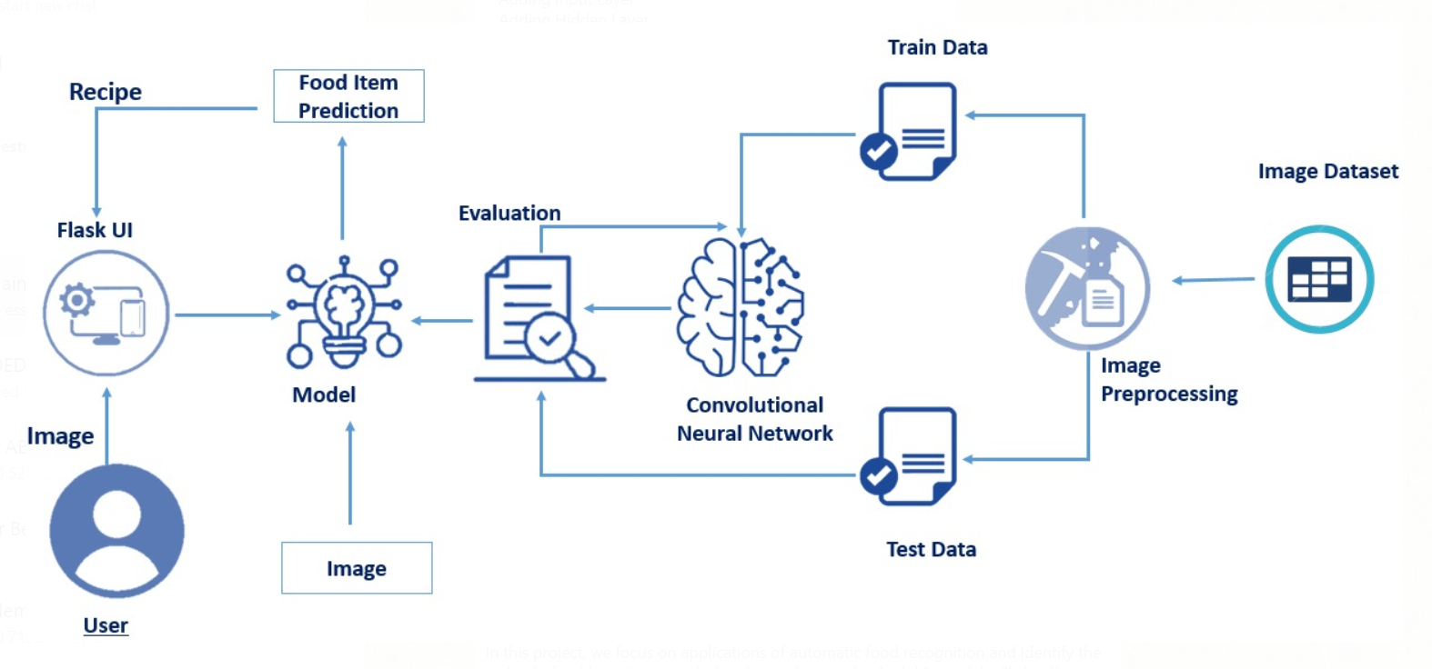

**PROJECT OBJECTIVE**

* Data Collection
  + Collect the dataset or Create the dataset
  + Data Preprocessing.
  + Import the ImageDataGenerator library
  + Configure ImageDataGenerator class
  + Apply ImageDataGenerator functionality to Trainset and Testset
* Model Building
  + Import the model building Libraries
  + Initializing the model
  + Adding Input Layer
  + Adding Hidden Layer
  + Adding Output Layer
  + Configure the Learning Process
  + Training the model
  + Save the Model
  + Test the Model
* Application Building
  + Create an HTML file
  + Build Python Code

**PROJECT STRUCTURE**

Create a Project folder which contains files as shown below:

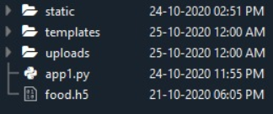

We are building a Flask Application which needs HTML pages stored in the templates folder and a python script app.py for serverside scripting

We need the model which is saved and the saved model in this content is food.h5

The static folder will contain JS and CSS files.

Whenever we upload an image to predict, that images are saved in the uploads folder.

**THEORETICAL ANALYSIS**

**DATA COLLECTION**

ML or DL depends heavily on data, without data, it is impossible for a machine to learn. It is the most crucial aspect that makes algorithm training possible. In Machine Learning projects, we need a training data set. It is the actual data set used to train the model for performing various actions.

You can collect datasets from different open sources like kaggle.com, data.gov, UCI machine learning repository, etc. As of now, you can download in the next step.

**DOWNLOAD THE DATASET**

The dataset used for this project was obtained from Kaggle. Please refer to the link given below to download the data set click here

<https://drive.google.com/drive/folders/1K8T3_OQz1Ri42LceZPAs4eQBU-y2DiJP>

The dataset contains three classes:

1.French Fries

2.Pizza

3.Samosa

**IMAGE PREPROCESSING**

Image Pre-processing includes the following main tasks

Import ImageDataGenerator Library.

Configure ImageDataGenerator Class.

Applying ImageDataGenerator functionality to the trainset and test set.

Note: The ImageDataGenerator accepts the original data, randomly transforms it, and returns only the new, transformed data.

**IMPORT ImageDataGenerator LIBRARY**

Image data augmentation is a technique that can be used to artificially expand the size of a training dataset by creating modified versions of images in the dataset.

The Keras deep learning neural network library provides the capability to fit models using image data augmentation via the ImageDataGenerator class.

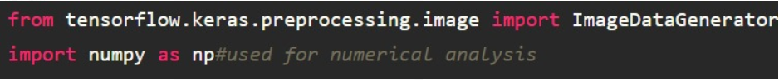

**CONFIGURE ImageDataGenerator CLASS**

ImageDataGenerator class is instantiated and the configuration for the types of data augmentation

There are five main types of data augmentation techniques for image data; specifically:

Image shifts via the width_shift_range and height_shift_range arguments.

Image flips via the horizontal_flip and vertical_flip arguments.

Image rotations via the rotation_range argument

Image brightness via the brightness_range argument.

Image zoom via the zoom_range argument.

An instance of the ImageDataGenerator class can be constructed.



**Apply ImageDataGenerator Functionality To Trainset And Testset**

Let us apply ImageDataGenerator functionality to Trainset and Testset by using the following code

For Training set using flow_from_directory function.

Arguments:

directory: Directory where the data is located. If labels are "inferred", it should contain subdirectories, each containing images for a class. Otherwise, the directory structure is ignored.

batch_size: Size of the batches of data. Default: 32.

target_size: Size to resize images to after they are read from disk.

class_mode:

- ‘int': means that the labels are encoded as integers (e.g. for sparse_categorical_crossentropy loss).

- 'categorical' means that the labels are encoded as a categorical vector (e.g. for categorical_crossentropy loss).

- 'binary' means that the labels (there can be only 2) are encoded as float32 scalars with values 0 or 1 (e.g. for binary_crossentropy).

- None (no labels).

There are 2400 images belonging to 3 classes (French fries, Pizza and Samosa)

For Testset

There are 600 images belonging to 3 classes (French fries, Pizza and Samosa)

validation_split: Optional float between 0 and 1, the fraction of data to reserve for validation.







**MODEL BUILDING**

The neural network model is to be built by adding different network layers like convolution, pooling, flattening, dropout, and neural layers.

In this milestone, we start building our model by:

1.Initializing the mode

2.Adding Convolution layers

3. Adding Pooling layers

4.Flatten layer

5.Full connection layers which include hidden layers

At last, we compile the model with layers we added to complete the neural network structure

**INITIALIZING THE MODEL**

Sequential model is a linear stack of layers. You can create a Sequential model by passing a list of layer instances to the constructor: from Keras. models import Sequential from Keras as follows.

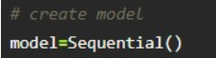

**ADDING CNN LAYERS**

For information regarding CNN Layers refer to the link

Link: https://victorzhou.com/blog/intro-to-cnns-part-1/

We are adding a convolution layer with activation function as “relu” and with a small filter size (3,3) and the number of filters (32) followed by a max-pooling layer.

Max pool layer is used to downsample the input.

Dropout layer is used to deactivate the neurons randomly. Dropout(0.2) indicates that 20 % of the neurons are deactivated.

Flatten layer flattens the input. Does not affect the batch size.

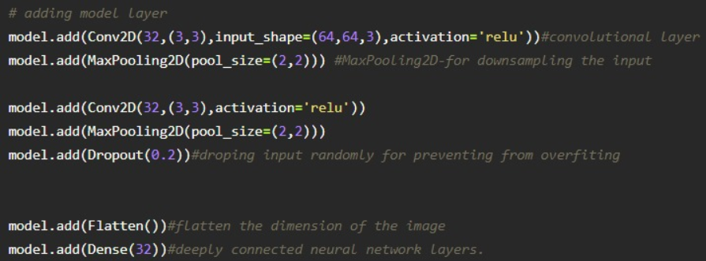

**ADDING DENSE LAYERS**

Dense layer is deeply connected neural network layer. It is the most common and frequently used layer.



Understanding the model is very important phase to properly use it for training and prediction purposes. Keras provides a simple method, summary to get the full information about the model and its layers.

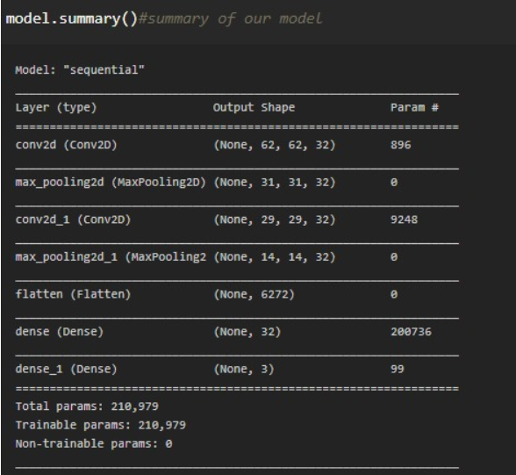

**CONFIGURE THE LEARNING PROCESS**

The compilation is the final step in creating a model. Once the compilation is done, we can move on to the training phase. Loss function is used to find error or deviation in the learning process. Keras requires loss function during the model compilation process.

Optimization is an important process which optimize the input weights by comparing the prediction and the loss function. Here we are using adam optimizer

Metrics are used to evaluate the performance of your model. It is similar to loss function, but not used in the training process



**TRAIN THE MODEL**

Now, let us train our model with our image dataset.

fit_generator functions used to train a deep learning neural network

Arguments:

steps_per_epoch : it specifies the total number of steps taken from the generator as soon as one epoch is finished and next epoch has started. We can calculate the value of steps_per_epoch as the total number of samples in your dataset divided by the batch size.

Epochs : an integer and number of epochs we want to train our model for.

validation_data can be either:

- an inputs and targets list

- a generator

- an inputs, targets, and sample_weights list which can be used to evaluate

the loss and metrics for any model after any epoch has ended.

validation_steps : only if the validation_data is a generator then only this argument

can be used. It specifies the total number of steps taken from the generator before it is

stopped at every epoch and its value is calculated as the total number of validation data points

in your dataset divided by the validation batch size.

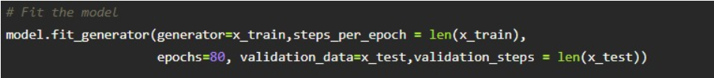

**SAVE THE MODEL**

The model is saved with .h5 extension as follows

An H5 file is a data file saved in the Hierarchical Data Format (HDF). It contains multidimensional arrays of scientific data.

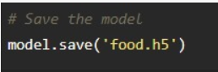

**TEST THE MODEL**

Evaluation is a process during the development of the model to check whether the model is the best fit for the given problem and corresponding data.

Load the saved model using load_model

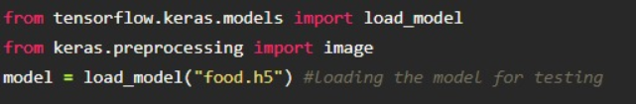

Taking an image as input and checking the results

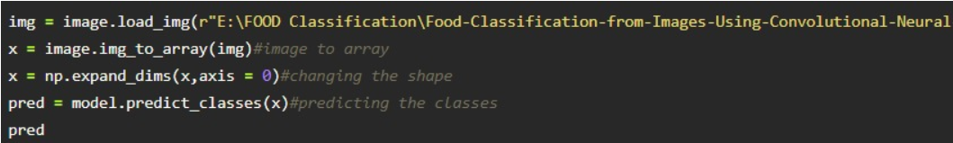

By using the model we are predicting the output for the given input image

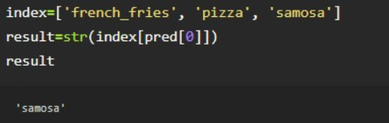

**APPLICATION BUILDING**

After the model is built, we will be integrating it into a web application so that users can interact with the model.

**CREATE HTML PAGES**

We use HTML to create the front end part of the web page.

Here, we created 4 html pages- about.html, base.html, index6.html, info.html.

about.html displays the home page.

Info.html displays all important details to be known about Malaria.

base.html and index6.html accept input from the user and predicts the values.

We also use JavaScript-main.js and CSS-main.css to enhance our functionality and view of HTML pages.

**BUILD PYTHON CODE AND TEST THE OUTPUT**

Let us build flask file’app.py’ which is a web framework written in python for server-side scripting. Let’s see step by step procedure for building the backend application.

The app starts running when “_name_” constructor is called in main.

render_template is used to return HTML file.

“GET” method is used to take input from the user.

“POST” method is used to display the output to the user.

Importing Libraries

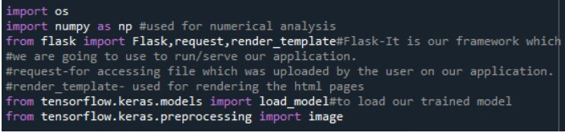

Routing to the HTML Page

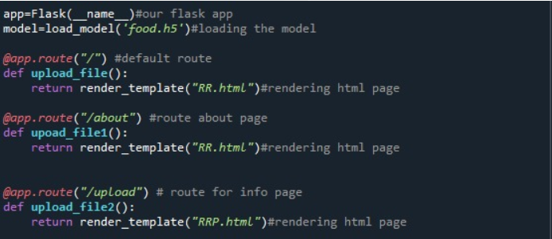

Showcasing prediction on UI

When the image is uploaded, it predicts whether the uploaded the image is French fries or pizza or samosa. If the image predicts value as 1, then it is displayed as “Pizza”. If the image predicts value as 0, then it is displayed as “French Fries”. If the image predicts value as 2, then it is displayed as “Samosa”.

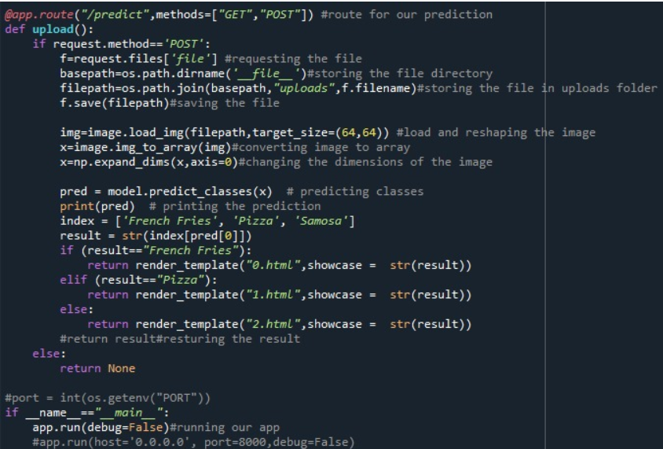

Run The app in the local browser

Open anaconda prompt from the start menu

Navigate to the folder where your python script is.

Now type “python app.py” command

Navigate to the localhost where you can view your web page

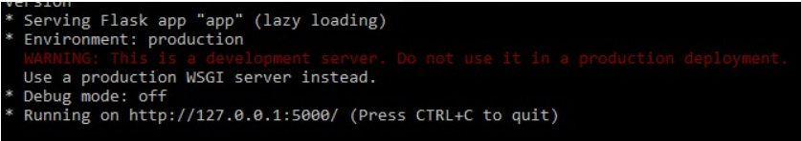

Then it will run on localhost:5000

Navigate to the localhost (http://127.0.0.1:5000/)where you can view your web page.

Let’s see how our about.html page looks like:

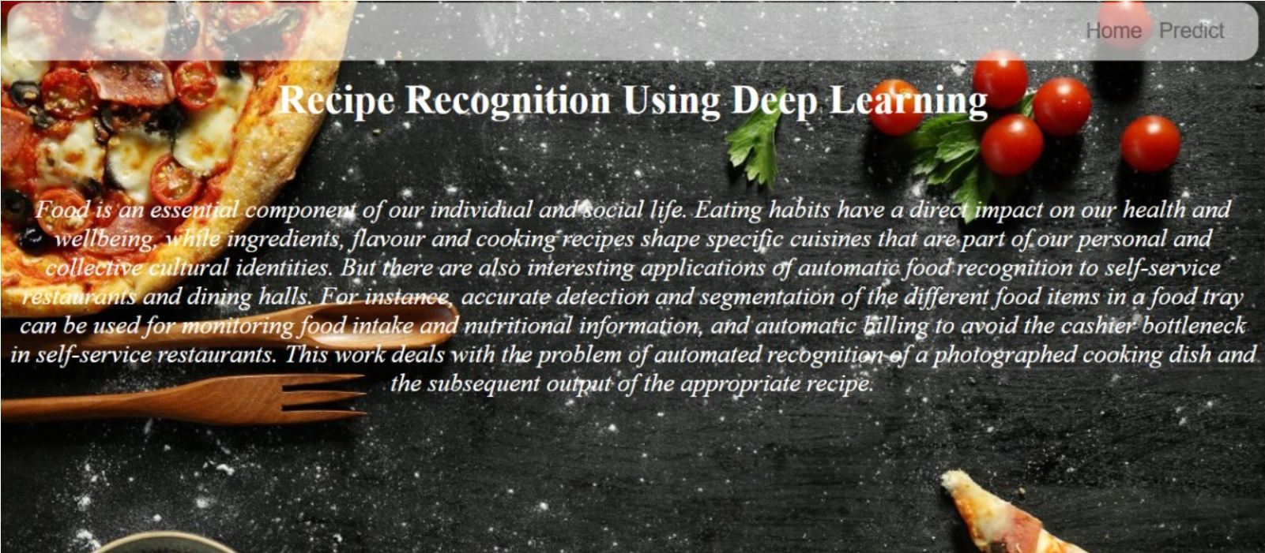

When “predict” button is clicked it will redirect to prediction page



In order to get the output one need to upload the image and click on recognize.

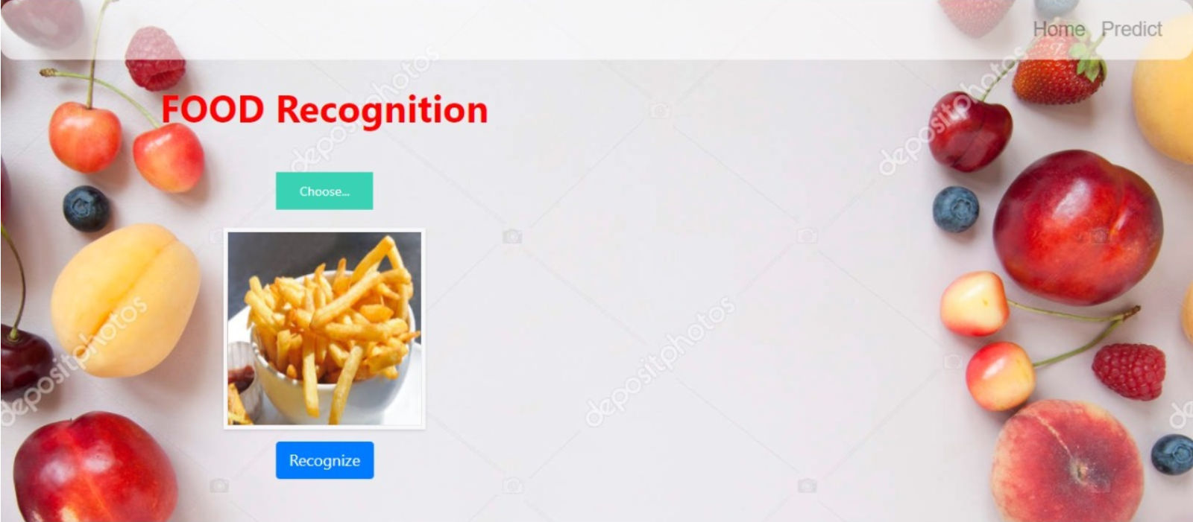

Upload the image and click on Predict button to view the result on “RRP.html” page on localhost.

Prediction-1:

If the uploaded image is French Fries the matching recipe for French Fries will be showcased.

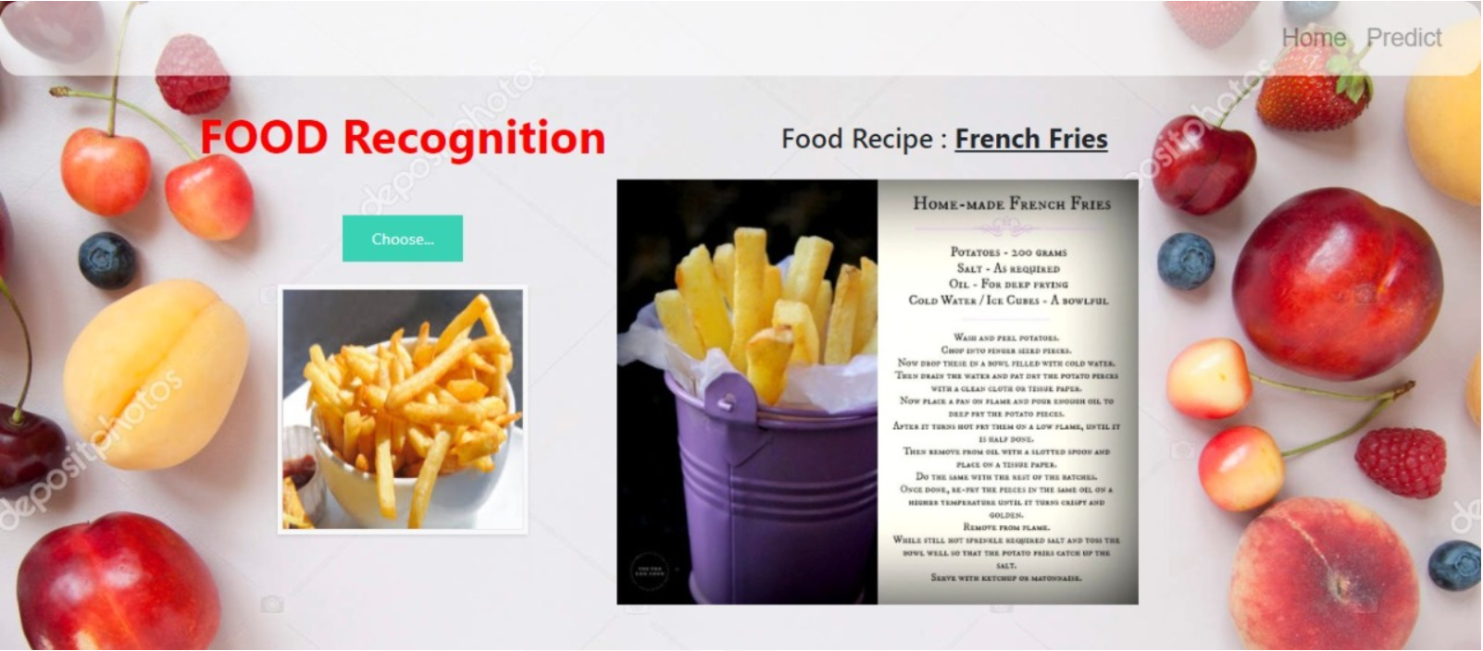

If the uploaded image is Pizza the matching recipe for Pizza will be showcased.



If the uploaded image is Samosa the matching recipe for Samosa will be showcased.

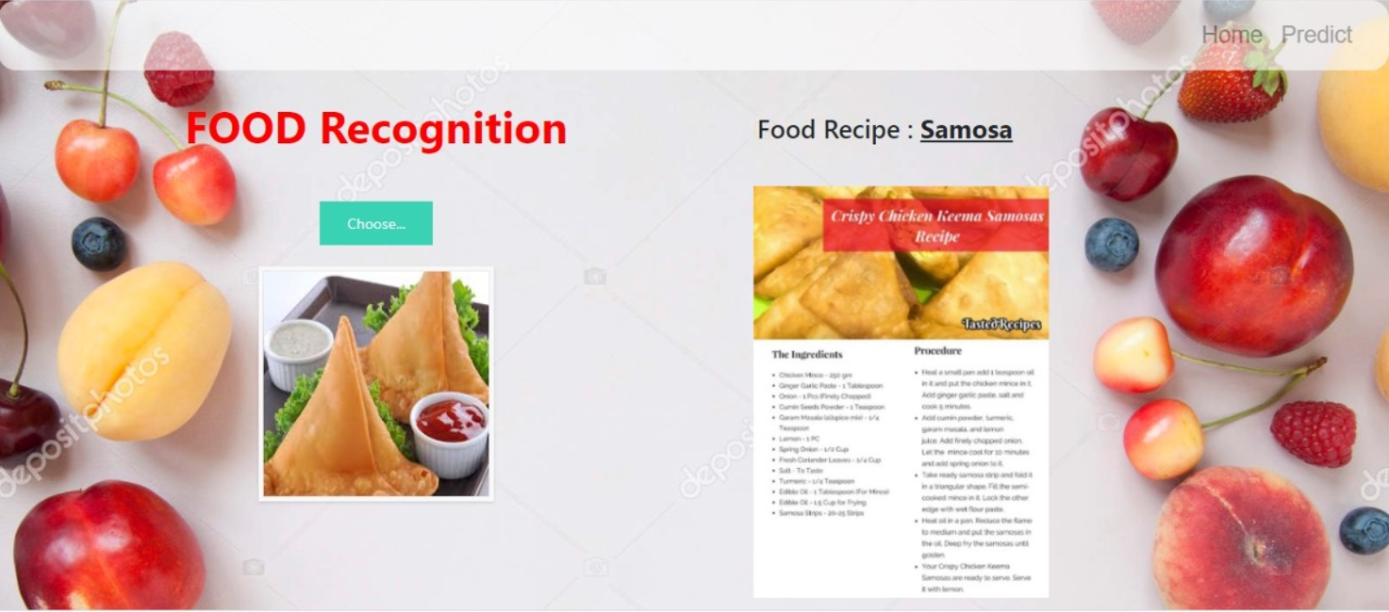

**CONCLUSION**

From this project, we have successfully:

* Known fundamental concepts and techniques of Convolutional Neural Network.
* Gained a broad understanding of image data.
* Known how to pre-process/clean the data using different data pre-processing techniques.
* Known how to build a web application using Flask framework.